CASE SERIES
EFFICACY OF VAJIKARANA IN SHUKRA DUSHTI W.S.R. TO OLIGO-ASTHENO-TERATAZOOSPERMIA SYNDROME: RETROSPECTIVE CASE SERIES
¹SUKUMAR N. NANDIGOUDAR, ²HARISH BABU H., ³RAGHAVENDRA Y.
¹Assistant Professor, ³PG Scholar, Department of Kayachikitsa KLEUs Shri BMK Ayurveda Mahavidyalaya PG Studies and Research Center, Belgaum, Karnataka, India
²PG Scholar, Department of Agada Tantra Evum Vyavahara Ayurveda, KLEUs Shri BMK Ayurveda Mahavidyalaya and PG Studies and Research Center, Belgaum, Karnataka, India
Corresponding author email address:-Babuharish50@gmail.com
Access this article online: www.jahm.in
Published by Atreya Ayurveda Publications, Ilkal-587125 (India) All rights reserved.
Received on: 09/01/2014, Revised on: 16/01/2014, Accepted on: 19/01/2014

Abstract:
Though population of the world is increasing day by day yet 20-30% populations of the world are the victims of the infertility. In India, 1 out of 10 couples suffer from infertility and about half of cases, men alone are contributory. Causes of Infertility are being impaired sperm production, or its function, impaired sperm delivery, due to vicious life style and environmental exposure. Oligoastheoteratazoosperima syndrome is the condition commonly prevailing and is concerned with semen production and function. In Ayurveda, Shukra dushti is considered to be the main cause for the male infertility. Absence or production of less quantity of semen is the main feature and explains 8 pathological entities which damages normal composition of semen. Vajikarana (Aphrodisiac therapy) is the specialized branch of Ayurveda dealing with Shukra Dushti and Klaibya (Semen disorders and Sexual Dysfunction). Though it mainly concentrates on Shukra dosha (seminal disorders) and Vandhyatwa (Infertility), but it also emphasizes about Vyadhi (Different pathologies), Functions of Dosha, Dhatu, Mala, Agni, (Metabolic conditions); Manas,- (Psychosomatic conditions); lifestyles and Poorvajanma kruta karma (Deeds of previous life). Srushti Fertility center is the specialty OPD which is attending the cases of infertility since 07yrs.the statistic revealed that, Out of 10 cases of Male infertility, 1-2 cases are diagnosed as OAT Syndrome. By proper counseling one can correct their skepticism about the thoughts of infertility; treatment is planned based on Pratipursuha siddhanta(theory of Individuality). Here is the presentation of 20 cases of OAT Syndrome coming under different types Shukra dushti.
Keywords: OAT syndrome, Shukra dushti, Vajikarana.

Introduction:
Though population of the world is increasing day by day yet 20-30% populations of the world are the victims of the infertility. In India, 1 out of 10 couples suffer from infertility and about half of the cases, men alone are contributory. Infertility means that a couple has failed to achieve a pregnancy within one year of regular (at least three times per month) unprotected intercourse. Male factor is present in approximately 40% of infertility cases. It is considered a male factor when an alteration in sperm concentration and/or motility and/or morphology could be found in at least one sample of two sperm analyses which comply with World Health Organization (WHO) 1999 guidelines collected between 1–4 weeks apart.¹
OAT syndrome:
In 40–60% of cases the only abnormality in the semen analysis and there is no relevant history or abnormality on physical examination and endocrine laboratory testing (idiopathic male infertility). Semen analysis reveals a decreased number of spermatozoa (oligozoospermia), decreased motility (asthenozoospermia) and many abnormal forms on morphological examination (teratozoospermia). Usually, these abnormalities come together and are described as the OAT-syndrome (oligo-astheno-teratozoospermia). Oligo-astheno-teratozoospermia (OAT Syndrome) is the condition presenting in males which is diagnosed by isolated astheno ± teratospermia (no alteration in sperm concentration); moderate (sperm concentration < 20 × 10⁶/mL and > 5 × 10⁶/mL); or severe (sperm concentration < 5 × 10⁶/ mL) ². Etiological factors are tabulated and listed below in the table no.1.²

Table no.1: Etiological factors for OAT syndrome.
Causes: | %
No demonstrable cause | 48.5
Sexual factors | 1.7
Urogenital infection | 6.6
Congenital anomalies | 2.1
Acquired factors | 2.6
Varicocele | 12.3
Endocrine disturbances | 0.6
Immunological factors | 3.1
Idiopathic abnormal semen (OAT syndrome) | 26.4
Other abnormalities | 3.0

OAT syndrome: Ayurvedic approach:
Prajotpadana (Fertility) is the main karma of Shukra dhatu³ and one of the main artha’s to be fulfilled by the individual in his lifespan.⁴ Vitiated Tridosha (three humours); impaired Agni; Impaired production of Dhatu (Rasa to Shukra) depletion of Soumya Bhava; all these factors impair the Shukra Dhatu. Ayurveda Encompasses these Tridoshaja dushti and explains 8 types shukra dushti i.e Vataja Pittaa, Kapahaj; Granti; Kunapagandhi shukra; Pooti; Puya; Mala samsrushta shukra.(seminal abnormalities)⁵
Case Series:

Here is the case presentation of 20 diagnosed cases of OAT Syndrome during the last 3years visiting to Srishti Ayurveda fertility center; a unit of KLE Ayurveda Hospital, Belgaum. Common complaints being no issues since 2-3 years of married life associated with anxiety, depression, semen disorders and Male sexual dysfunctions. Treatment given was based on signs and symptoms, complaints, Dosha Dushya etc. and semen analysis. Statistical data was interpreted by using semen analysis of before and after treatment with Shodhan wherever necessary along with Shamanoushadhis. Data was statistically tested using Student paired ‘t’ test and significance was tested for 0.005% confidence level.
Materials and Methods:
Methodology: Case files of the patient attending fertility center of KLE Ayurveda Hospital, Belgaum were taken, and the diagnosed OAT syndromes were ruled out and enrolled for retrospective case studies irrespective of their cast, Socio-economic status.
Inclusion Criteria:
- Age limit above 22yrs.
- Sperm count- < 30million.(Oligospermia)
- Motility- < 40% or less.
- Morphology- < 40-50%.(Asthenospermia)
Exclusion Criteria:
- Patients who discontinued their treatment.
- Patients with Secondary/higher complications.
- Patients with Azoospermia.
- Patients with Necrozoospermia.
Methodology for the study:
The cases were selected from the databases. The cases which come under inclusive criteria were ruled out and included for the study.
Parameters: Semen Analysis, Sperm count, Sperm Motility (RLP, SLP, NP) Sperm
Morphology (Head; Neck, Body, Tail abnormalities.) were taken as parameters.
Results: Data generated from the semen analysis was subjected for “t” Test and P value was checked for 95% and significance was obtained.

Table No-2: Diagnosis of patients as per Retopariksha, Prakruti, Reto varna, Reto gandha wise
Reto dusti wise distributions of patients |  | Prakriti wise distribution, |  | Shukra Varna wise distributions |  | Sukraganda wise distribution
RETO PAREEKSHA | No. of Patients | Prakriti | No of patients | Varna | No.of pts | Gandha | No of patients
Tanu retas | 11 | Vatapittaja | 7 | Shweta | 13 | Visraganda | 13
Picchila retas | 04 | Vata  kaphaja | 8 | Peeta | 07 | Nirganda | 06
Ruksha retas | 01 | Kapha  pittaja | 5 | _ | _ | Putiganda | 01
Granthibhuta retas | 02 | - | - | - | - | - | -
Anyadhatu samasrita | 01 | - | - | _ | _ | - | -
Putipuya retas | 01 | - | - | - | - | - | -

Table no.3: Treatment given as per Ayurvedic Diagnosis and Contemporary diagnosis
Ayurvedic Diagnosis of Cases |  | Ayurvedic treatment -OAT Syndrome based on Sperm Analysis
Reto Dushti | Treatment modalities adopted | Condition | Treatment given
Vaataja | Ruksha- Amalaki (Emblica officinalis) ; Shatavari grita;  Vidaryadi grita  Amrutaprasha grita | Oligospermia < 30 million/ml | Shatavari(Asperagus racemosa), Mushali (),  Sharkara(Saccurum officinarum), Ashvagandha (Withanania somnifera)  Vidari kanda (Pureria tuberosa), Amalaki(Emblica officinalis), Masha ()  Mamsa rasa, Ghee, Milk,
Pittaja | Pittashamaka dravyas –  Chanadana(santalum album),  Sariva(Hemedesmus indicus),  Amalaki (Emblica officinalis),  Guduchi(Tinospora cordifolia) | Asthenozoospermia-motility less than 50% | Kapikacchu(Mucuna Pruriens) , Pippali(piper longum) , Shunti(zingiber officinalae) , Amalaki(Emblica officinalis) , Makaradvaja rasa.
Kaphaja | Palasha kshara , Saindahava, Pippali(piper longum), Shunti(zingiber officinalae), Shilajatu, Chandraprabha vati, Dadeema (Punica granatum)  Ati picchila:-Triphala ,Lohabhasma ,Ashwagandha(Withanania somnifera)  , Kapikacchu(Mucuna Pruriens), Kokilaksha(Hygrocanthes Aspergaus), Navayasa Loha | Teratozoospermia  (>60% abnormal forms) | Aswagandha, kapikacchu, samudraphena, Amalaki, Guduchi, Trivanga bhasma, Rajata bhasma Chandrodaya, Poorna chandroday rasa
Kaphaja |  | Azoospermia | Rajata. Makaradwaja,  Pippali(Piper longum), Maricha(Piper nigrum),  Shilajatu, Loha Bhsma,  Haritaki(Terminalia chebula)  -
Pooti | Samudraphena | Azoospermia
Puya | Shukra shodhaka dravyas ,  Katphala,  kushta,  Samudra phena.  Chyavanaprasha, Sarivadyasava, Chandraprabha vati,  Gokshuradi guggulu | Azoospermia

Table No.4: showing statistical interpretation of the parameters- (Before and after treatment)
Parameters | Mean + SEM | P value | Significantly different  <0.05?
Semen volume in ml | 0.2250+0.2130 | 0.3040 | No
Sperm count  In millions | 9.900+2.062 | 0.0001 | Yes
Total motility% | 13.75+2.783 | <0.0001 | Yes
RLP% | 4.250+2.441 | 0.0978 | No
SLP% | 4.500+2.203 | 0.0553 | No
NP% | 3.750+2.016 | 0.0784 | No
Immobile | 13.25+2.863 | 0.0002 | Yes
Total abnormality% | 13.00+3.487 | 0.0014 | Yes
Head% | 11.75+2.839 | 0.0006 | Yes
Mid piece% | 0.800+2.755 | 0.7746 | No
Tail% | 1.500+1.817 | 0.4194 | No
Headless% | 2.250+1.174 | 0.0705 | No

Semen Quantity: The Average semen Quantity of these 20 cases was between 0.5ml to 2ml before treatment. After proper Shodhana and Shukra Janaka / Vardhaka (drugs which purify/ increase the production of sperm) line of treatment there was marked increase in the production of semen which was significant (Mean+ SEM 0.2250+0.2130) with the P value 0.3040, which was significant at the confidence level of 95%.(Graph-1&Table no-4)
Sperm count: The study showed significant increase in the count after treatment the significant was (Mean + SEM 9.900+2.062) with the P value 0.0001 which was significant at 95%. Thus it shows that treatment was effective for increasing sperm count. (Graph-2&Table no-4)
Sperm Motility: The Total motility was found significant in the study (Mean +SEM 13.75+2.783) but the RLP (4.750+2.441), SLP (4.4500+2.023), NP (3.750+2.016) showed no significant results. But there was significant changes observed in the reduction of immobile sperm cells (13.15+2.863) with a P value 0.0002.(Graph-3&Table no-4)
Sperm Morphology: The total abnormality was significantly controlled (13.00+3.487) with a ‘p’ value 0.0014 significance at 95%. But there was no drastic changes saw in the midpeice abnormalities ( 0.800+ 2.755); tail abnormalities ( 1.500+ 1.817); headless ( 2.250+1.174) but the head deformities were significantly reduced with (11.75+2.839) with p value 0.0006 at the 95% confidence level (Graph-4&Table no-4)

Thus present retrospective study shows that the treatment were successive with respect to increase in sperm count, Sperm motility, Sperm morphology. Though there was clinically improvement in the conditions of the patients but the sperm quantity, RLP%, SLP%, NP%, Midpeice defects, tail and headless did not show any significant changes. Thus over all the study enlightens us about the importance and success rate of vajikarana chikitsa when clinically applied based on pratipurusha siddhanta.
Discussion:
Life style and stress is the main etiological factor affecting the semen Quantity and Quality. OAT refers to the condition which hampers both semen production and its normal morphology (Terato) and function (Astheno).⁽⁶⁾ When vataadi dosha gets vitiated by the foresaid nidaana’s these settle into shukra dhatu and causes defects in Quantity, count, motility (RLP , SLP, NP Immobile), Morphology.

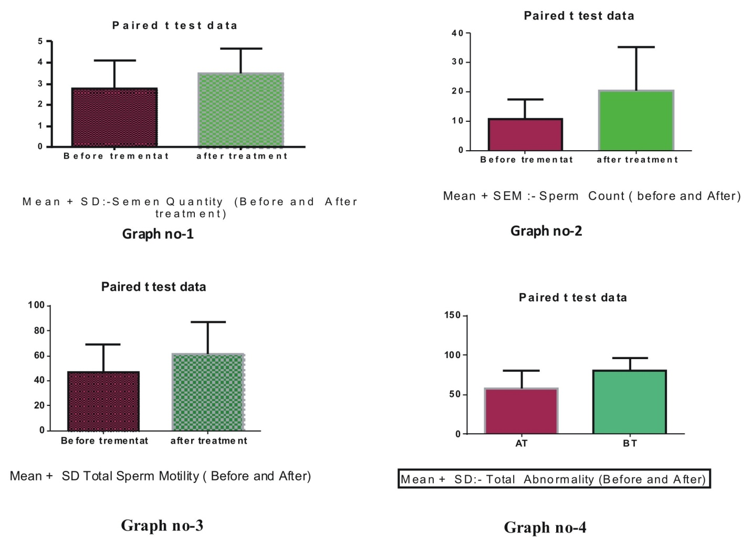
Vataja dushti leads to defects in quantity due to roukshata and kapha kshaya, also causing defects in motility- i.e. Decreased RLP, SLP and increased non progressive and immobile sperms. Pitta due to its Paaka guna when vitiated produces defects in quantity and morphological variations as – sperm count reduction (Oligo), altered morphology (Terato)- headless, headform deformities, midpiece deformities, tail deformities. When there is kapha kshaya it deforms the spermatogenesis as it causes depletion of rasa, leading to changes like alteration of pH, viscosity, consistency, and liquefaction time.
Vajikarana chikitsa: –
Is the specialized branch of Ayurveda mainly dealing with dushti’s of shukra dhatu and its management.⁷ Though it deals mainly with shukra dhatu but the fundamental principles laid down are mainly based on Pratipurusha siddhanta i.e purusha, prakruti, dosha, dhatu, mala, dosha dooshya samurchana, kala, vaya, deha (Table no-3) etc. thus it is always not possible to fix the standard protocol for every condition, but the basic principle/ chikitsa sutra will be the same. Thus drugs which are suitable and indicated in such conditions are utilized as per the patient condition. The main line of treatment in practice is – koshta shodhana by either Shodhanokta virechana karma or nitya virechana karma and vamana (Koshta shodhana). Line of treatment in vajikarana is intended for shukra janana/vardhana karma, shukra shodhana karma, shukra virechana karma, shukra sthambhana karma.
- Thus drugs like ashwagandha, shatavari, kapikacchu, mushali, sharkara, mamsa rasa, ghrita, ksheera, ikshu rasa, vidari, amalaki, masha, virechana and vrushya basti etc are known for Shukra janana/vardhana. These can be utilized in case of oligospermia, or decreased semen quantity- Vataja retodushti.
- The amalaki, kushta, katphala, ela, sariva, chandana, vidanga, bhallataka, etc are given to correct impairment in spermatogenesis- shukra shodhana action. Thus there will be production of healthy sperm both morphologically and physiologically (motility wise).
Conclusion:
The Aim of This retrospective study is not to show or set standard for the particular medicines used in these conditions. The idea being is to, establish and show the medical fraternity that there is wide range of treatment options available in the Vajikarana Chikitsa and it can be implemented in day to day practice based on the principle of Pratipurusha siddanta. Success rates are also promising and encouraging which lead us to step in further.
Acknowledgement:
We are highly thankful to Dr.B.S.Prasad, Principal KLE BMK Ayurveda Mahavidyalaya PG Studies and Research center Belgaum for his support and Encouragement.

References:

- Asian J Androl. Idiopathic oligo-astheno-teratozoospermia. 2006; 8:143–15.
- G.R. Dohle et al. European Urology. 2005; 48:703–711
- Vagbhata, Arunadatta& Hemadri, (Ed) Bhishagacharya Harisastri Paradakara Vaidya. Ashtanga Hrudayam, 8thEd .Varanasi Choukhambha Orientalia; Sutra Sthana; t; 11th chapter; verse:4:193.
- Yadavaji Trikamaji, editor. Charaka Samhita of Charaka, chikitsasthana, vajikarana adhyaya, prathama paada verse no.3 2nd edition, Varanasi; Chowkhambha orientalia Series;2011; p.390
- Yadavaji Trikamaji, editor. Sushruta samhita of sushruta, Shareera sthana shukrashonita shuddhi shareera verse no.3 8th edition, Varanasi; Chowkhambha orientalia Series;2005; p.344
- Arch Androl, Etiology of male infertility and Oligo-, Astheno-, Teratospermia (OAT), 1997; 39:197.
- Yadavaji Trikamaji, editor. Charaka Samhita of Charaka, chikitsasthana, vajikarana adhyaya, chaturtha paada verse no.51 2nd edition, Varanasi; Chowkhambha orientalia Series; 2011; p.397.
Cite this article as: Sukumar N. Nandigoudar, Harish Babu H., Raghavendra Y. Efficacy of vajikarana in shukra dushti W.S.R. to oligo-astheno-teratazoospermia syndrome: retrospective case series. Journal of Ayurveda and Holistic Medicine (JAHM). 2014; 2(1).p.51-57.

Source of support: Nil, Conflict of interest: None Declared.

